Coordinated Entry Referral Workflow

Overview:

- How the Counts Report dashboard works.
- Click on Outstanding Incoming Referrals to view pending Referrals.
- Navigate to the Client Profile and click on Service Transactions.
- View Entire Service History and click the pencil next to Referral.
- Follow the Referral resolve steps. Save.
- Homepage Counts Report will update and the Incoming Referral will be resolved.

On your HMIS Homepage you will notice the Counts Report box. The box contains an Incoming Referrals and Outstanding Incoming Referrals count report.

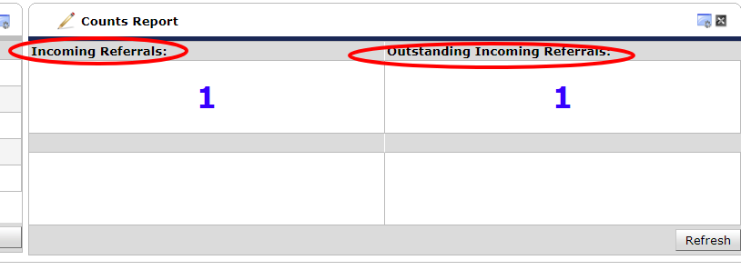
Incoming Referrals: This number will keep track of the total number of referrals sent to the project.

Outstanding Incoming Referrals: This number will track the number of referrals sent to the provider that require action. When the referrals is resolved this number will decrease.

Both blue numbers can be clicked on for more information and as a method for navigating to the client referral.
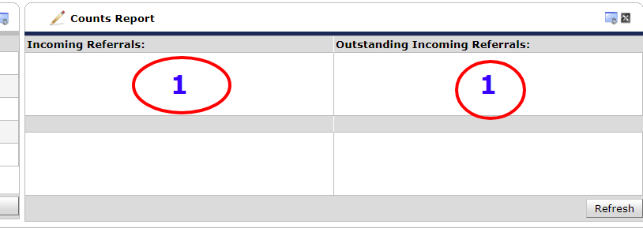
Click on the outstanding Incoming Referrals number.

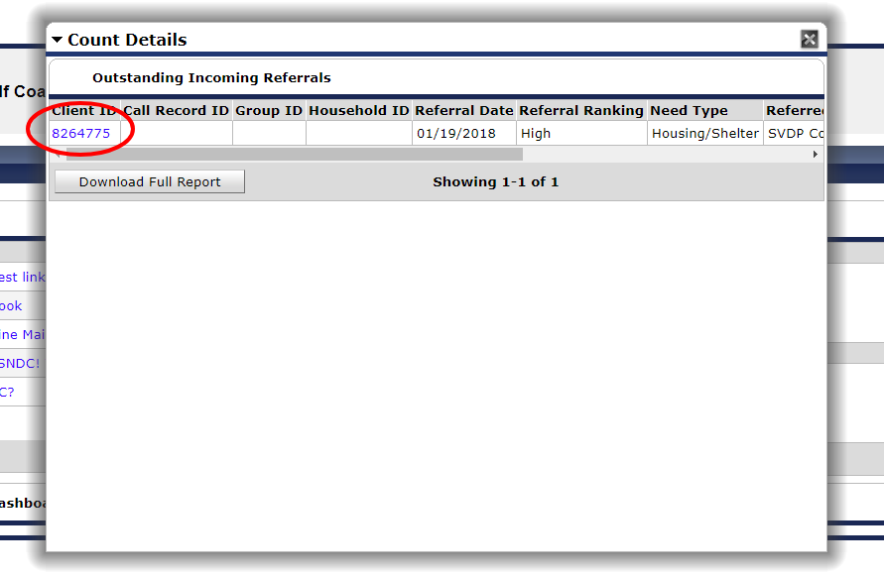

This is what the report will look like. Clicking on the blue Client ID will bring you to the Client Profile. The report also features the referral date, referral ranking, need type, referred by, referred to, and referral outcome.
The rest of these data elements can be seen by dragging the navigation bar at the bottom of the report screen.

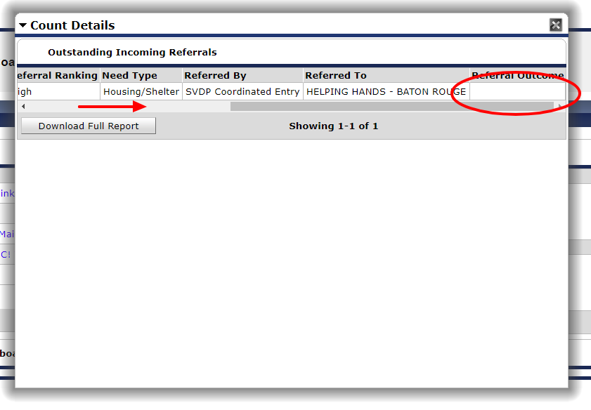

Notice that Referral Outcome is blank. Drag the navigation bar back and click on the blue Client ID.

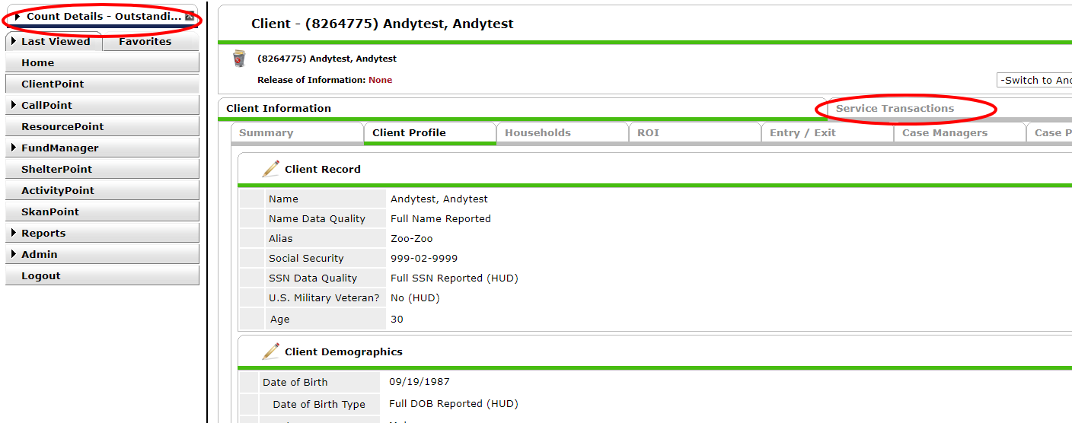
You will be immediately taken to the Client Profile after clicking on the Client ID.

Note: If you are working on multiple clients on the referral list you can click on the report in the top left corner.

Next, click on the Service Transactions tab.

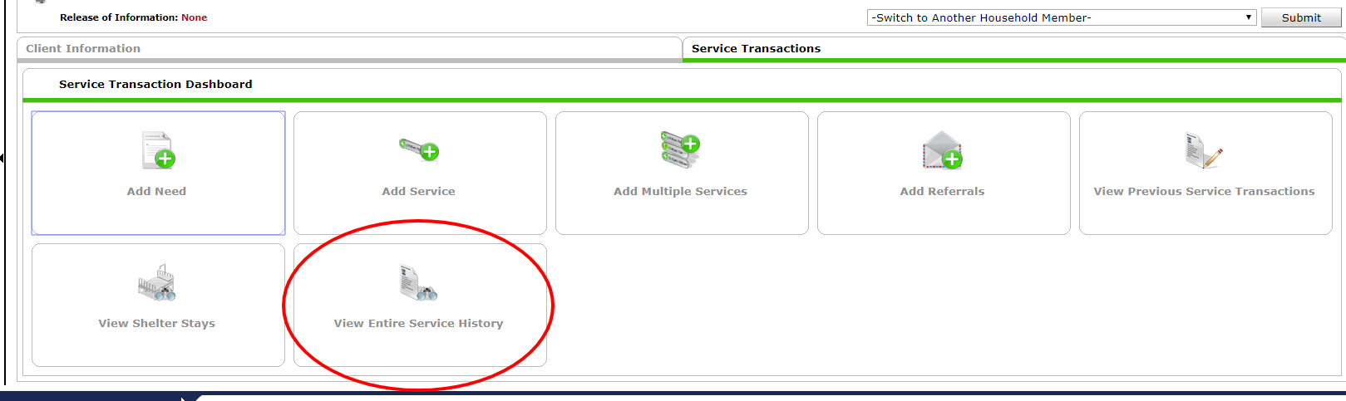

Click on View Entire Service History.

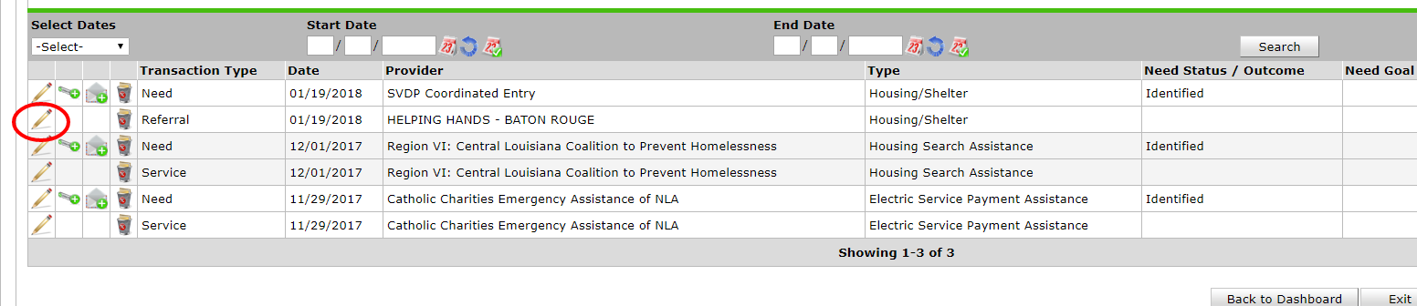

Click the edit pencil icon next to the Referral for your project.
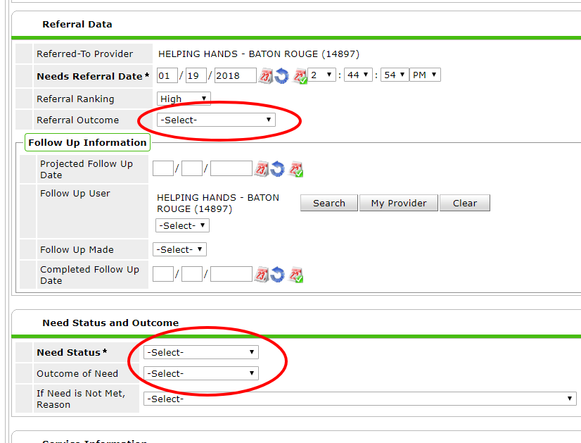

In order to resolve a referral a Referral Outcome, Need Status, and Outcome of Need must be completed.

To accept a referral that is being contacted:
(This acknowledges that the agency has viewed and accepted to work with the referral. This is the stage at which the agency is trying to contact the client and set a meeting):

1. Click Referral Outcome and select Accepted.
2. Click the dropdown box for Need Status and select In Progress.
3. To finish, click Save & Exit. The referral has been accepted.

To accept a referral that has been accepted into the program:
(after acknowledging the referral and the agency accepting the participant into the program, finalize the referral acceptance):

1. Click Referral Outcome and select Accepted.
2. Click the dropdown box for Need Status and select Closed.
3. Click the dropdown box for Outcome of Need and select Fully Met.
4. To finish, click Save & Exit. The referral has been accepted, closed, and housed.

To reject a referral:

1. Click Referral Outcome and select Declined or Cancelled. A new drop down box will appear: Use Cancelled if the applicant is not reachable. Use declined for all other rejections.
2. If Canceled or Declined, Reason. Please select the appropriate Reason.
3. Click the dropdown box for Need Status and select Closed.
4. Outcome of Need should be marked as Not Met.
5. In If Need is Not Met, Reason dropdown box select the appropriate reason. The Reason should be the same for Referral Outcome and Outcome of Need.
6. Click Save & Exit.

Summary
Resolving a Referral

Referral Outcome | Referral Outcome  Reason | Need Status | Need Outcome | Need Outcome  Reason | Description
Accepted | Leave blank | In Progress | Leave blank | Leave blank | This acknowledges that the agency has viewed and accepted the referral. This is the stage at which the agency is trying to contact the participant and set a meeting.
Accepted | Leave blank | Closed | Fully met | Leave blank | Participant was accepted into the program and is now housed.
Declined | Did not meet eligibility or statutory requirements | Closed | Not met | Did not meet eligibility or statutory requirements | Participant is not eligible to receive the service provided by the program.
Declined | Program reached capacity | Closed | Not Met | Program reached capacity | Accepted a referral prioritized at a higher level and need to decline the other referrals
Declined | Client refused service | Closed | Not Met | Client refused service | Participant was offered the program service and declined to enter the program.
Cancelled | unreachable | Closed | Not met | unreachable | Despite reasonable attempts to contact participant, they are not reachable.

After clicking Save & Exit return to the Homepage. The Count Report number for Outstanding Incoming Referrals should have decreased by one. If not, try clicking on Refresh. If the number still does not decrease be sure to review the above steps.

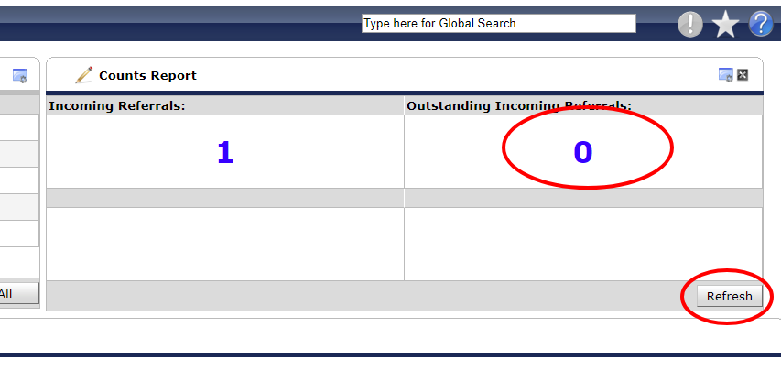

The Incoming Referral number should remain constant, regardless of accepting or declining referrals. The Incoming Referral number tracks all clients referred to the project and clicking on the blue number will allow you to review past referral actions as well as revisit a client in order to make corrections to referral errors.

